**DISCOVERING OUTLOOK GROUPS – OUTLOOK WEB**

At Company, we have many groups used for Collaboration through SharePoint, Teams, and Outlook.

If you are an owner or member of one or more of these groups, the group “should” appear in your Outlook mailbox, under the inbox folders. If you do not see the group mailboxes, you can also “Discover” them, using the steps below:

1. Right-mouse click “Groups” in your Outlook sidebar:

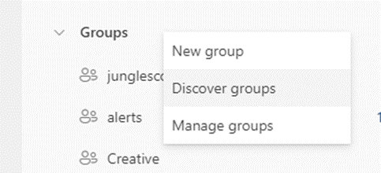

1. Type in the name of the Group you want to have in your inbox, and then click the Group when it shows up below. It will now be a part of your Groups.

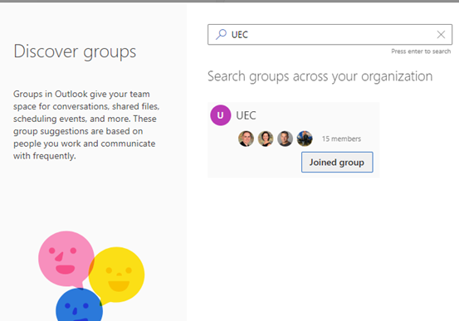

If you have any questions, or issues with Groups, please contact [ITHelpDesk@company.com](mailto:ITHelpDesk@andeza.com) or chat in the ITHelpDesk Group on Teams. You may also put a task into the IT Help Desk Planner/Task board.